20th September 2017

**YOKOHAMA Forever Forest Project Plants 500,000th Tree**

The “YOKOHAMA Forever Forest” project, started back in 2007, achieved its goal of 500,000 trees planted on 14th September. Chairman Tadanobu Nagumo, President Masataka Yamaishi joined others to celebrate planting of the commemorative tree at the Hiratsuka Factory. To build upon the project's success to date, YOKOHAMA will continue various related activities, including planting trees at new plants, providing saplings to various regions, promoting wild bird watching events, and monitoring CO2 absorption amounts. We also will contribute to biodiversity conservation efforts within our business premises and in the surrounding communities.

The "YOKOHAMA Forever Forest" is a global tree-planting project that targeted the planting of 500,000 tree saplings at YOKOHAMA manufacturing sites, sales offices, and related facilities in Japan and overseas by 2017, the 100th anniversary of Company’s founding. Under the guidance of Mr. Akira Miyawaki (plant ecologist and Emeritus Professor of Yokohama National University) who has extensive experience in planting trees in Japan and abroad, the "YOKOHAMA Forever Forest" project has been sponsoring planting activities based on the "potential natural vegetation" concept advocated by Mr. Miyawaki. The project’s goals include "Developing participants' environmental awareness," "Helping decelerate global warming," "Disaster prevention and the formation of environmental conservation forests," and "Preserving biodiversity." The project has promoted the direct participation of YOKOHAMA employees and others in creating forests by collecting acorns, nursing saplings, and then planting them. Tree plantings have been held in 34 locations in Japan, China, Taiwan, Vietnam, Thailand, the Philippines, Indonesia, India, the United States and Russia, with the participation of 53,611 people, including YOKOHAMA employees and their family members as well as residents of the local community (data as of 20th August 2017).

The knowhow gained through the “YOKOHAMA Forever Forest” project has also been applied to activities outside the YOKOHAMA Group, thereby expanding the project’s contributions to society. For example, in the town of Otsuchi-cho in Iwate Prefecture’s Kamihei-gun, an area that suffered extensive damage during the 2011 Great East Japan Earthquake, YOKOHAMA has supported the town’s efforts to create a forest, called the “Chinkon no Mori,” as part of its reconstruction plan. Over four years starting in 2012, YOKOHAMA played a major role in the development of the town’s "Heisei no Mori," a model for the larger “Chinkon no Mori”. YOKOHAMA has also cooperated in the creation of coastal disaster prevention forests in Miyagi Prefecture’s Iwanuma City and in Shizuoka Prefecture’s Kakegawa City. In addition, the Company has supported numerous tree-planting activities undertaken by local governments, schools, companies, and NPOs, donating a total of 312,341 saplings.

In line with its CSR management vision “To Build a Trusted Identity as a Contributing Member of the Global Community,” YOKOHAMA is promoting various activities targeted at environmental protection and contributions to its local communities and the broader society. YOKOHAMA’s CSR activities are highly regarded overseas as well as in Japan, and the Company has been included in the FTSE4Good Index of companies demonstrating strong Environmental, Social and Governance (ESG) practices for thirteen straight years. YOKOHAMA’s CSR activities have also been recognized by inclusion in the initial Supplier Engagement Leaderboard, a short list of companies recognized for their environmental efforts throughout the supply chain by the CDP (formerly Carbon Disclosure Project), a nongovernmental organization conducting surveys and ratings of the environmental protection activities of the world’s leading corporations. In October 2016, the Company’s response to climate change was recognized by its inclusion in the CDP’s Climate A List.

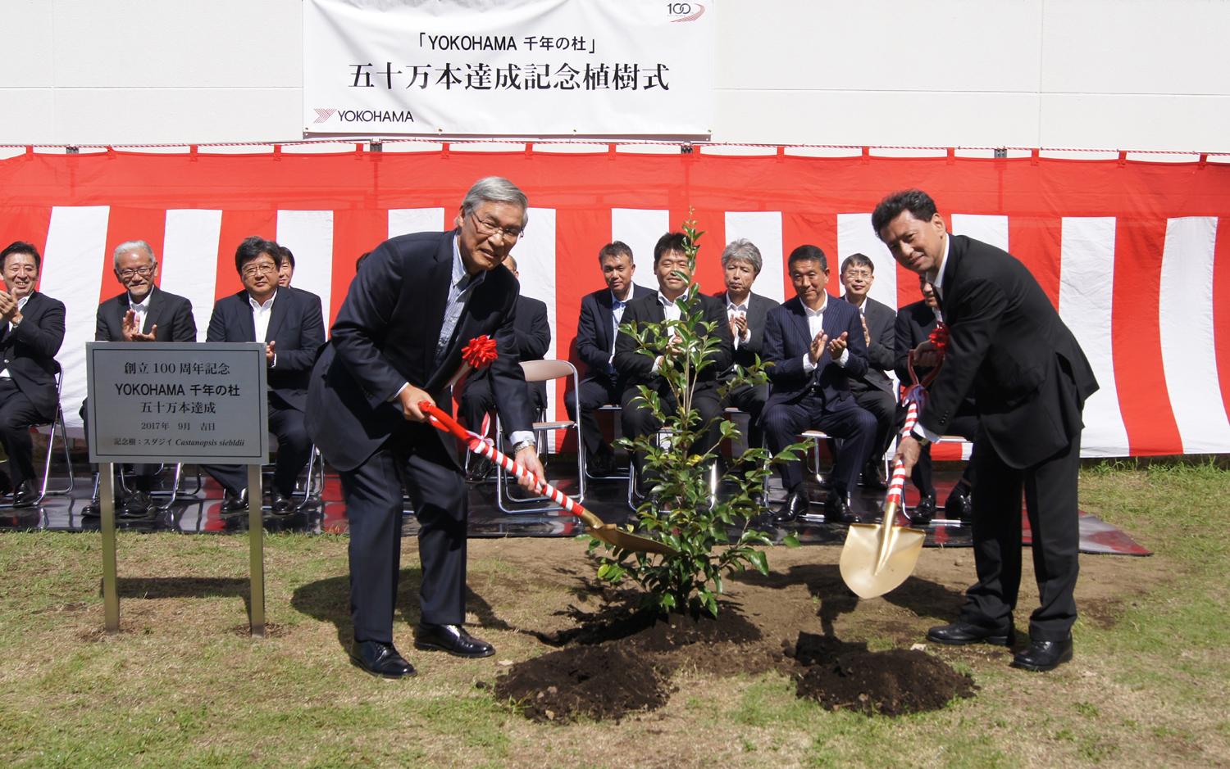

*Yokohama Rubber Chairman Tadanobu Nagumo (left) and President Masataka Yamaishi participating in commemorative tree planting*